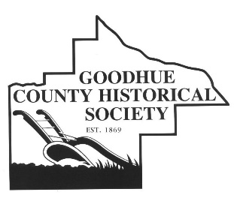
Goodhue County Historical Society
1166 Oak Street
Red Wing, MN 55066

Certificate of Program Completion

Continuing Education Units (CEU’s)

This is to certify that ________________________________________________ has completed the following approved staff development activities sponsored by the Goodhue County Historical Society.

Topic: Teacher Advisory Panel

Collaborator: Goodhue County Historical Society

Dates of Program(s): Multiple meetings throughout the 2017/2018 academic school year: November 20, 2017, February 5, 2018, March 12, 2018, and May 21, 2018

Location(s): Goodhue County Historical Society, Zumbrota-Mazeppa Elementary School, and Cannon Falls Middle School

Total Clock Hours Possible: 8

Total Clock Hours Earned: _________

Category: D – Site, district, sate, national, or international curriculum development (Does not include regular lesson planning)

State Requirements

A. Positive behavioral intervention strategies

B. Accommodations, modifications and adaptations of curriculum, materials and instruction X

C. Key warning signs for early on-set mental illness in children and adolescents

D. Reading preparation

E. Technology

F. English Learners

Reflection Statement
A statement that demonstrates professional reflection and growth in best teaching practices, including among other things, practices in meeting the varied needs of English Learners, from children to adult.

S SEE ATTACHED

___________________________ _______________________________________
Lindsey Rindo Signature of Participant
Goodhue County Historical Society I attest the information on this certificate is true
I attest the information on this certificate is to the best of my knowledge.
true to the best of my knowledge.
Please return this form to your Continuing Education Representative

