Proposal for a
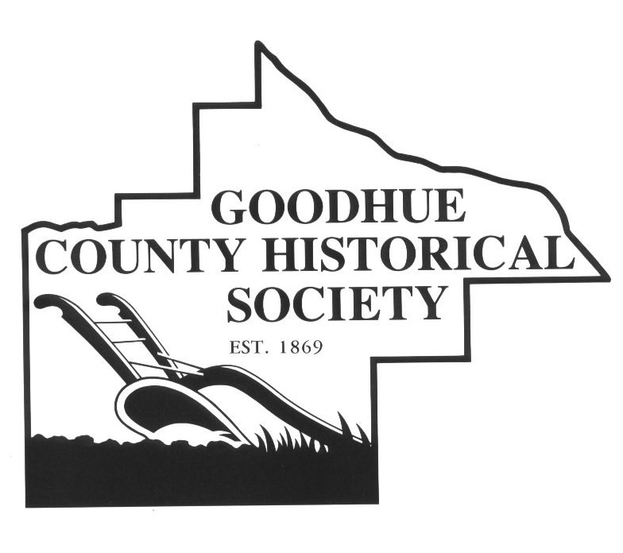

Teacher Advisory Panel with the

Goodhue County Historical Society

Description:
The Goodhue County Historical Society (GCHS) strives to create beneficial educational experiences that teachers will utilize both on site at the Goodhue County History Center and in classrooms throughout Goodhue County. In order for this to happen, the Historical Society believed it would be best to ask teachers what they want and then collaborate with them to make their social studies wish lists a reality. The Goodhue County Historical Society seeks teachers with a passion for social studies to join a Teacher Advisory Panel (TAP). This group of dedicated educators would collaborate with the Education & Outreach Coordinator to develop meaningful educational experiences that meet state standards and engage students in hands-on learning. GCHS hopes to include at least one educator from each school district so that these programs would incorporate the needs of each school district.
In return for educators’ expertise in curriculum development and knowledge of state standards, the Goodhue County Historical Society would offer continuing education units and opportunities to participate in professional development workshops related to the types of programs TAP and GCHS would produce.
Objectives:
- Develop hands-on curriculum that utilizes the Goodhue County Historical Society’s resources
- Provide professional development opportunities for local educators
- Provide resources to aid teachers throughout Goodhue County with meeting state standards that are more difficult to reach with classroom resources alone
- Strengthen the relationship between GCHS and local schools
What is a Teacher Advisory Panel?
The Teacher Advisory Panel would consist of local teachers and the Education & Outreach Coordinator. Together, this group would meet on a consistent basis (at least quarterly) to identify the best possible methods for GCHS’s resources to aid teachers in meeting state standards. In order to remain flexible, logistics such as, where to meet, when to meet, how often to meet, and specific state standards will be determined by the group during the first meeting. The first meeting will take place at the Goodhue County History Center.
At the conclusion of the school year, the Goodhue County Historical Society will provide certificates with clock hours to help teachers obtain continuing education units. Teachers will receive one clock hour for each hour that teacher participated in a TAP meeting or other professional development opportunities provided by GCHS.

